**Functional Blocks of Accelerometer Based Gesture Control Robot**

In accelerometer based gesture control robot hand motion is used to drive the robot. Accelerometer which works on acceleration is used for this purpose.

**Functional Blocks:**

1. Arduino UNO
2. DC motors
3. Accelerometer
4. HT12D ( Decoder IC at Receiver side)
5. HT12E ( Encoder IC at transmitter side)
6. RF pair
7. Motor Driver L293D
8. 9 Volt Battery

### Accelerometer (ADXL335):

The gestures/motion made by hand is recognized by an acceleration measuring device called accelerometer (ADXL335).

An accelerometer (ADXL335) is a three-axis (X, Y, Z) acceleration measuring device. This device is also found in smartphone to move car/person towards left, right when phone is tilted in respective direction.

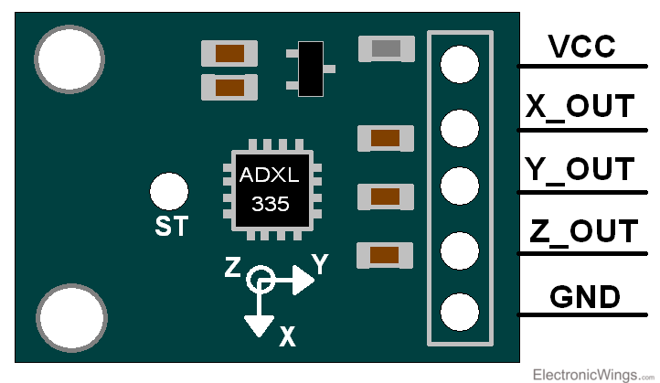

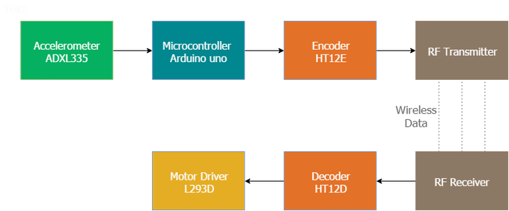

**Functional Block Diagram of Accelerometer based gesture controlled Robot.**

Here the accelerometer reads the X Y Z coordinates when we make gestures by hand and send the X Y Z coordinates to the Arduino (here we don’t need the Z-axis we need only two coordinated X and Y So neglect the Z coordinate). The Arduino checks the values of coordinates and sends a 4-bit code to the Encoder IC. The Encoder passes the data to the transmitter and the transmitted data is received by the RF receiver. The receiver sends the 4-bit code to the Decoder IC and the decoder passes it to Motor Driver IC. Later the motor driver makes the decision to turn the two motors in the required direction.

**Power Supply:**

Two power supply are needed: one for the transmitter and one for the receiver. The receiver circuit needs to powered using 12V supply (depending upon Motor operating voltage is 9/12V motor) and the transmitter circuit can be powered using a 9V battery.

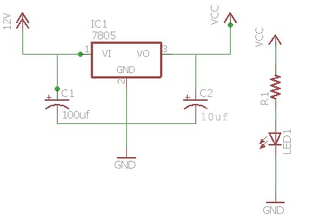

**Circuit diagram of power supply on receiver side**

**Transmitter Section (Remote):**

The transmitter section consists of an accelerometer that detects the hand gesture and sends the data to the Arduino. Later Arduino sends data to the Encoder IC in accordance with the data received from the accelerometer and the data is transmitted to the receiver. Accelerometer can use 3.3v/5v power supply. Check datasheet of device before supplying any voltage to avoid damage to IC.

**Connection Diagram for transmitter Section :**

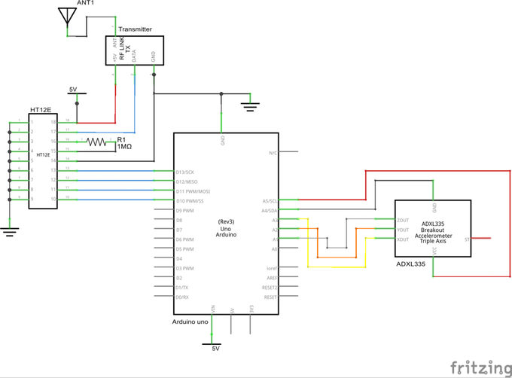

**Receiver Section circuit Diagram:**

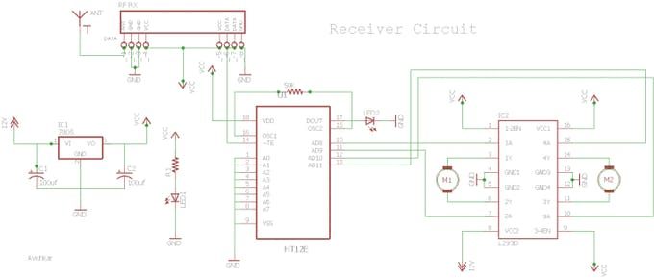

The receiver circuit consists of 2 IC (HT12D decoder, L293D motor driver), RF receiver module.

There are 2 LEDs in the receiver board, one lights up when the power supply is given to the receiver and the other when the power supply is given to the transmitter circuit. The LED near the IC HT12D should light up and this provides you a valid transmission (VT) when power is given at the transmitter.

**Types of Gestures recognized by Robot:**

The robot can be designed for recognizing five sets of gestures: forward, backward, left, right and stop. Illustrations are as follows:

 



**Functional Blocks of Home Automation using RF Control**